Lesson10 What is Auto Scaling

**Notes: -**

**1-autoscaling is used to increase the resources such as CPU cores and memory by upgrade the app service plan to understand the heavy load**

**2-Baisc make autoscaling manually and up to 3 VM**

**3-Standard make autoscaling automatically by set scale in conditions when load reach 80% create 3 VM for 3 hours and can handle 10 VM**

**4-AutoScaling happen on Standard service plan or higher**

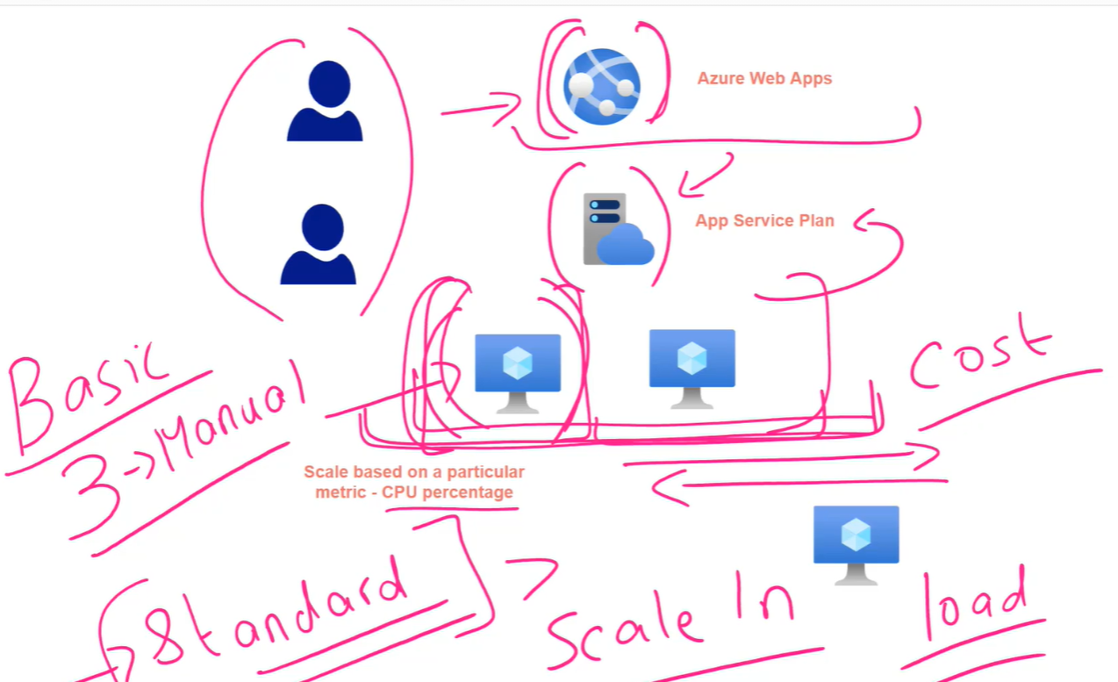

**Implement Auto Scaling in Azure App Service**

**Notes: -**

**1-in basic service plan I can make manual autoscaling not automatic autoscaling**

**And handle up to 3 VM**

**Settings > Scale out (App service plan)**

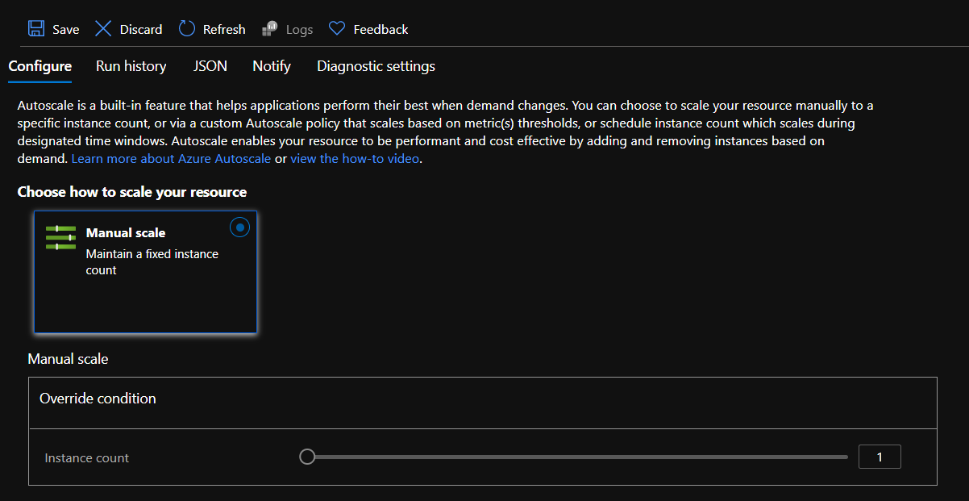

**2-by go on Settings > Scale Up to standard > we have ability now to scale up manually or with custom auto scale**

**(Can create multiple scale conditions)**

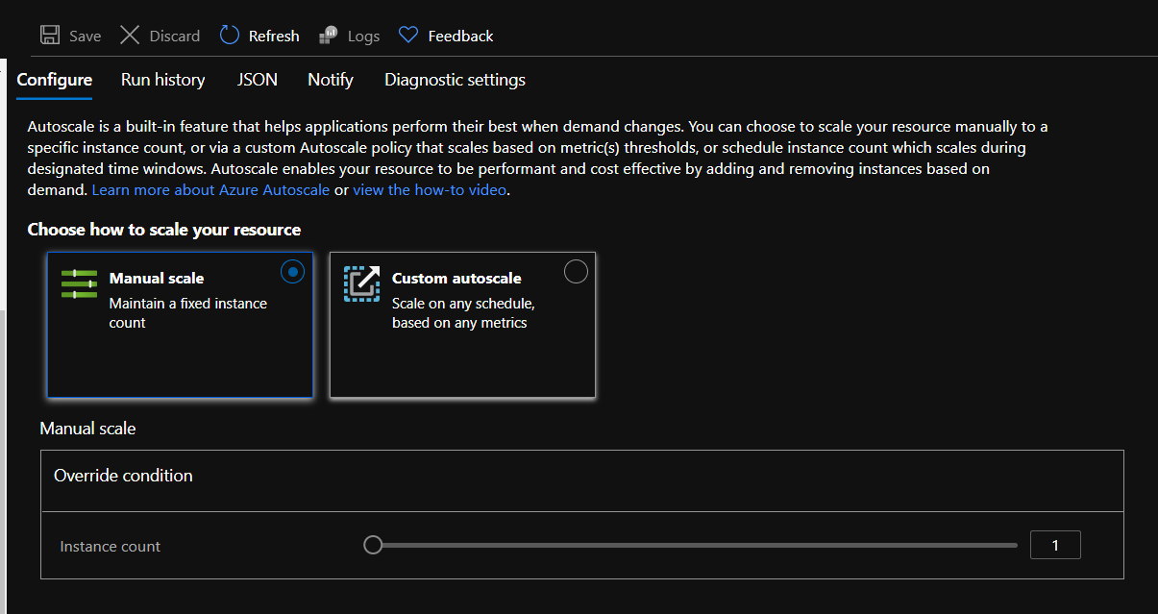

**4-on scale rule you can specify on the current resource or link with another azure resources**

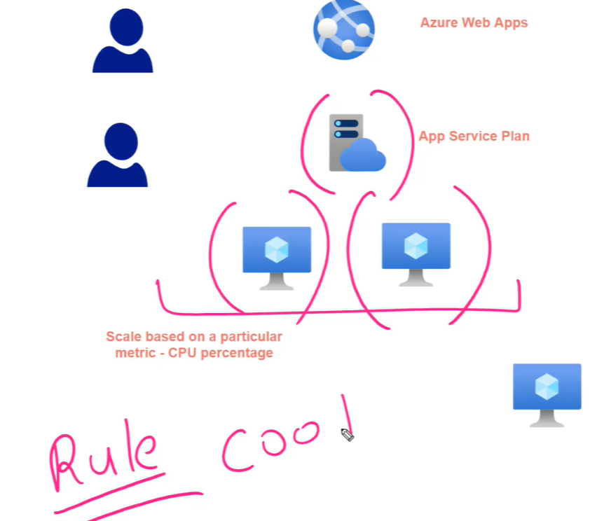

**7-you can see the history of scale out result on settngs > scale out (App service plan)**

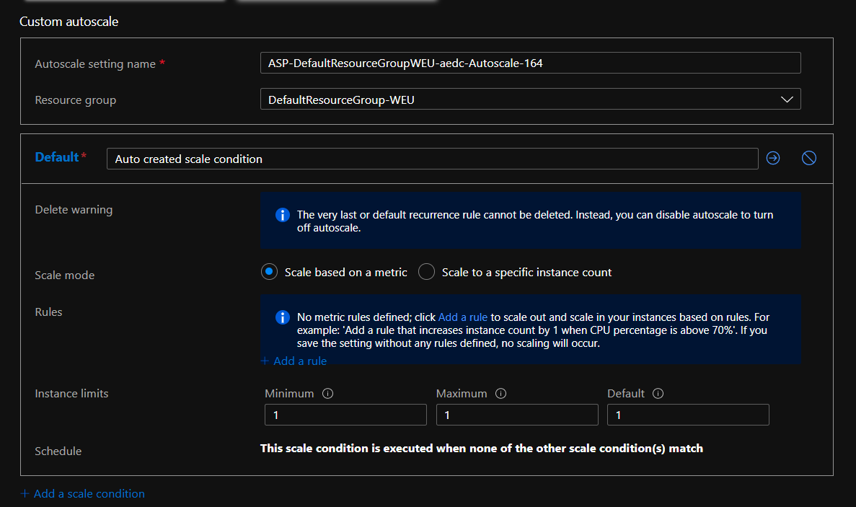

**5-you can select the maximum instances (can create two or three under needed traffic) created under this scale rule**

**(We can add rule such if the CPU percentage to 70% for Duration 10 give him 5 minute cool down time to create load balancer to balance the data traffic)**

**And create instance count number on that rule**

**cool down period: the time needed to create new VM and make load balancer to balance traffic between two VM**

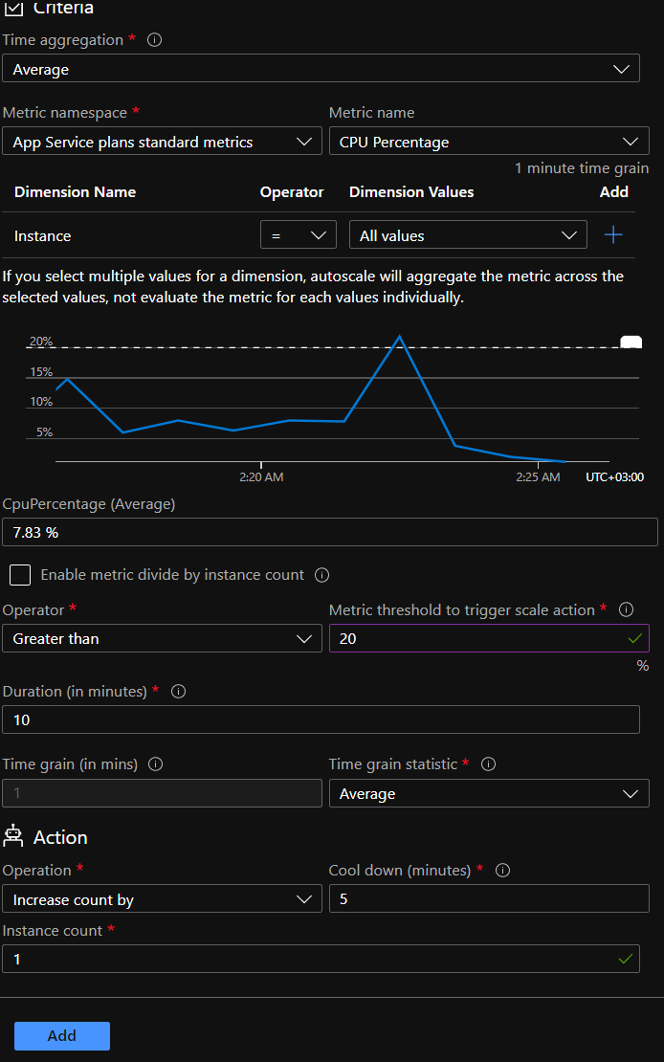

**7-you can set scale condition that set the start and end time that applied that override the instance count from all the rules inside it**

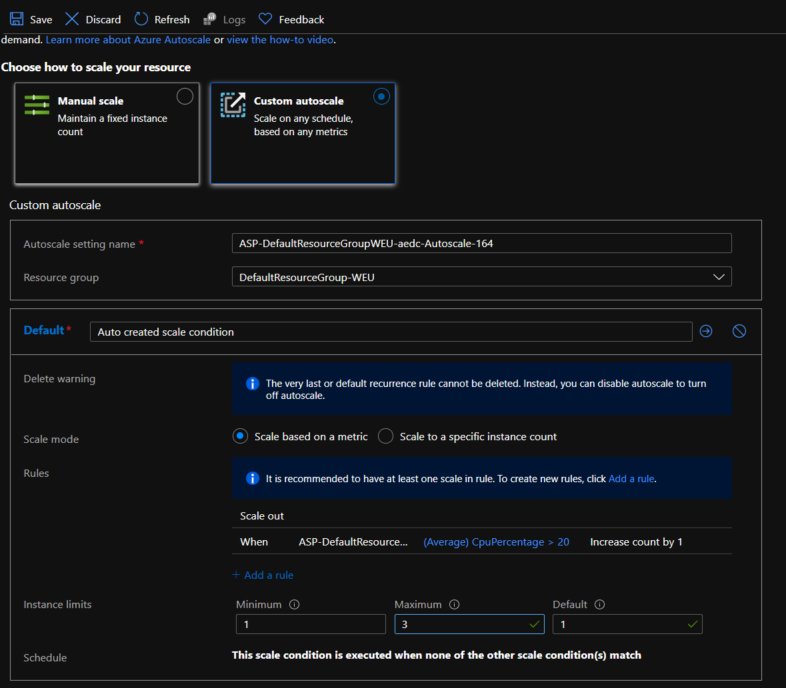

**So not of these rules will reach over 3 instances of VM under these periods**

**(of course, you can add multiple scale conditions with multiple rules inside it)**